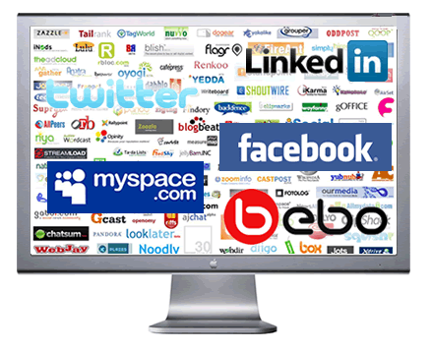
#GODIGITAL
As technology
becomes
personalized, the
communication
solutions must
keep pace with it.
iPads, iPhones or
Blackberry devices take mobile portability to another level and any communication via this medium should appeal and enthuse the users.
Thus, any communication solutions developed that works on the principle of “Audience first” is a winning solution. As the frontiers of information and technology expand, learning and advertising communication solutions have a greater role to play for organizations in the future.
#GODIGITAL TRAINING DAY 2016 will set the standard in affordable training in the field of Digital Technology.

TRAINING DAY
LEARN
SHARE

GROW

“You have to know how it works, if, you want to control it! Technology.”

- Shaleea “Lucki” Johnson
Isn’t the digital world grand? No waiting days or weeks for stuff to be delivered. And the discounts companies can offer are amazing! Now, thanks to digital media, if you aren’t bringing in the sales you want or you’re in an honest to goodness sales slump, you can get real help in getting your pipeline filled quickly for next to nothing. An effective brand experience can be leveraged if the user is able to simultaneously cover all forms of digital media.
In any form of communication, involving the audience is more effective than passive communication. When the learners or the consumers are pro-actively engaged through a suitable medium of communication, the message is easily preserved. This is desired the capture for any Entrepreneur’s, or Small Business seeking to solidify its brand in a saturated market of competitors.
As technology becomes personalized, the communication solutions must keep pace with it. iPads, iPhones or Blackberry devices take mobile portability to another level and any communication via this medium should appeal and enthuse the users.
Thus, any communication solutions developed that works on the principle of “Audience first” is a winning solution. As the frontiers of information and technology expand, learning and advertising communication solutions have a greater role to play for organizations in the future.
#GODIGITAL TRAINING DAY 2016 will set the standard in affordable training in the field of Digital Technology.






Much like the Industrial Revolution in 19th Century American History,
the Digital Revolution is a 21st Century revolt of the way that
business is now conducted. Star Quality Firm is a full service
digitally revolutionary communications company. As a full
service digital and rich media brand management firm,
Star Quality Firm helps entrepreneurs and
entertainment industry professionals
achieve their Digital Media Branding and
Marketing goals to perfection. The question
“Are You Ready for the Digital Revolution”
came to fruition when I noticed that many
businesses have not set their sites on the benefits
that the Internet and other forms of digital media
have to offer.
Being in business in the “Digital Revolution” means
being business ready in an era that allows
companies to be hands on with their clients thru
brand management, rich media, and social
networking processes.
Mauris odio nisi, bibendum quis, vehicular sed, tempus at, orci. Vestibulum vel dolor non ante bibendum mollis.
The Team | Founder: Shaleea "Lucki" Johnson | Director of Marketing: Adrienne Lawson
Company Overview | Star Quality Firm takes an integrated approach to your digital and graphic design needs to meet your marketing goals. We help to formulate your message, develop your marketing strategy, create branded "print" materials, as well as your online material presence, and actively promote your business through advertising, e-mail marketing campaigns or various forms of online media.  Our inspiration to take Digital Revolution to the next level is the brand placement and independence that the online and rich media world brings. With over 10 years of entertainment industry experience, we have seen the industry take a complete 360-degree turn within the last 20 years. Much like “Big Tobacco”… “Big Records”, “Big Media” & “Big Radio” once ruled the playing field with complete ownership and entitlement to the music that was being created by our favorite artists. Now, the digital revolution age has taken back the rights of entrepreneurs and gifted them the ability to create and build a brand much like news stations and larger corporations do. This is where Star Quality Firm steps in the picture.
Products | Our Services Include:  - Marketing Strategy & Branding  - Graphic Design & Print Design  - Electronic Media & Online Visibility  - Social Media Communication  - Web Development & Programming
Mission | Star Quality Firm takes pride in helping minority entrepreneurs & professionals achieve their personal branding and new media goals to perfection.
Awards | The Presidents Award: Bill Clinton Outstanding Community Service
Website | http://www.starqualityfirm.com

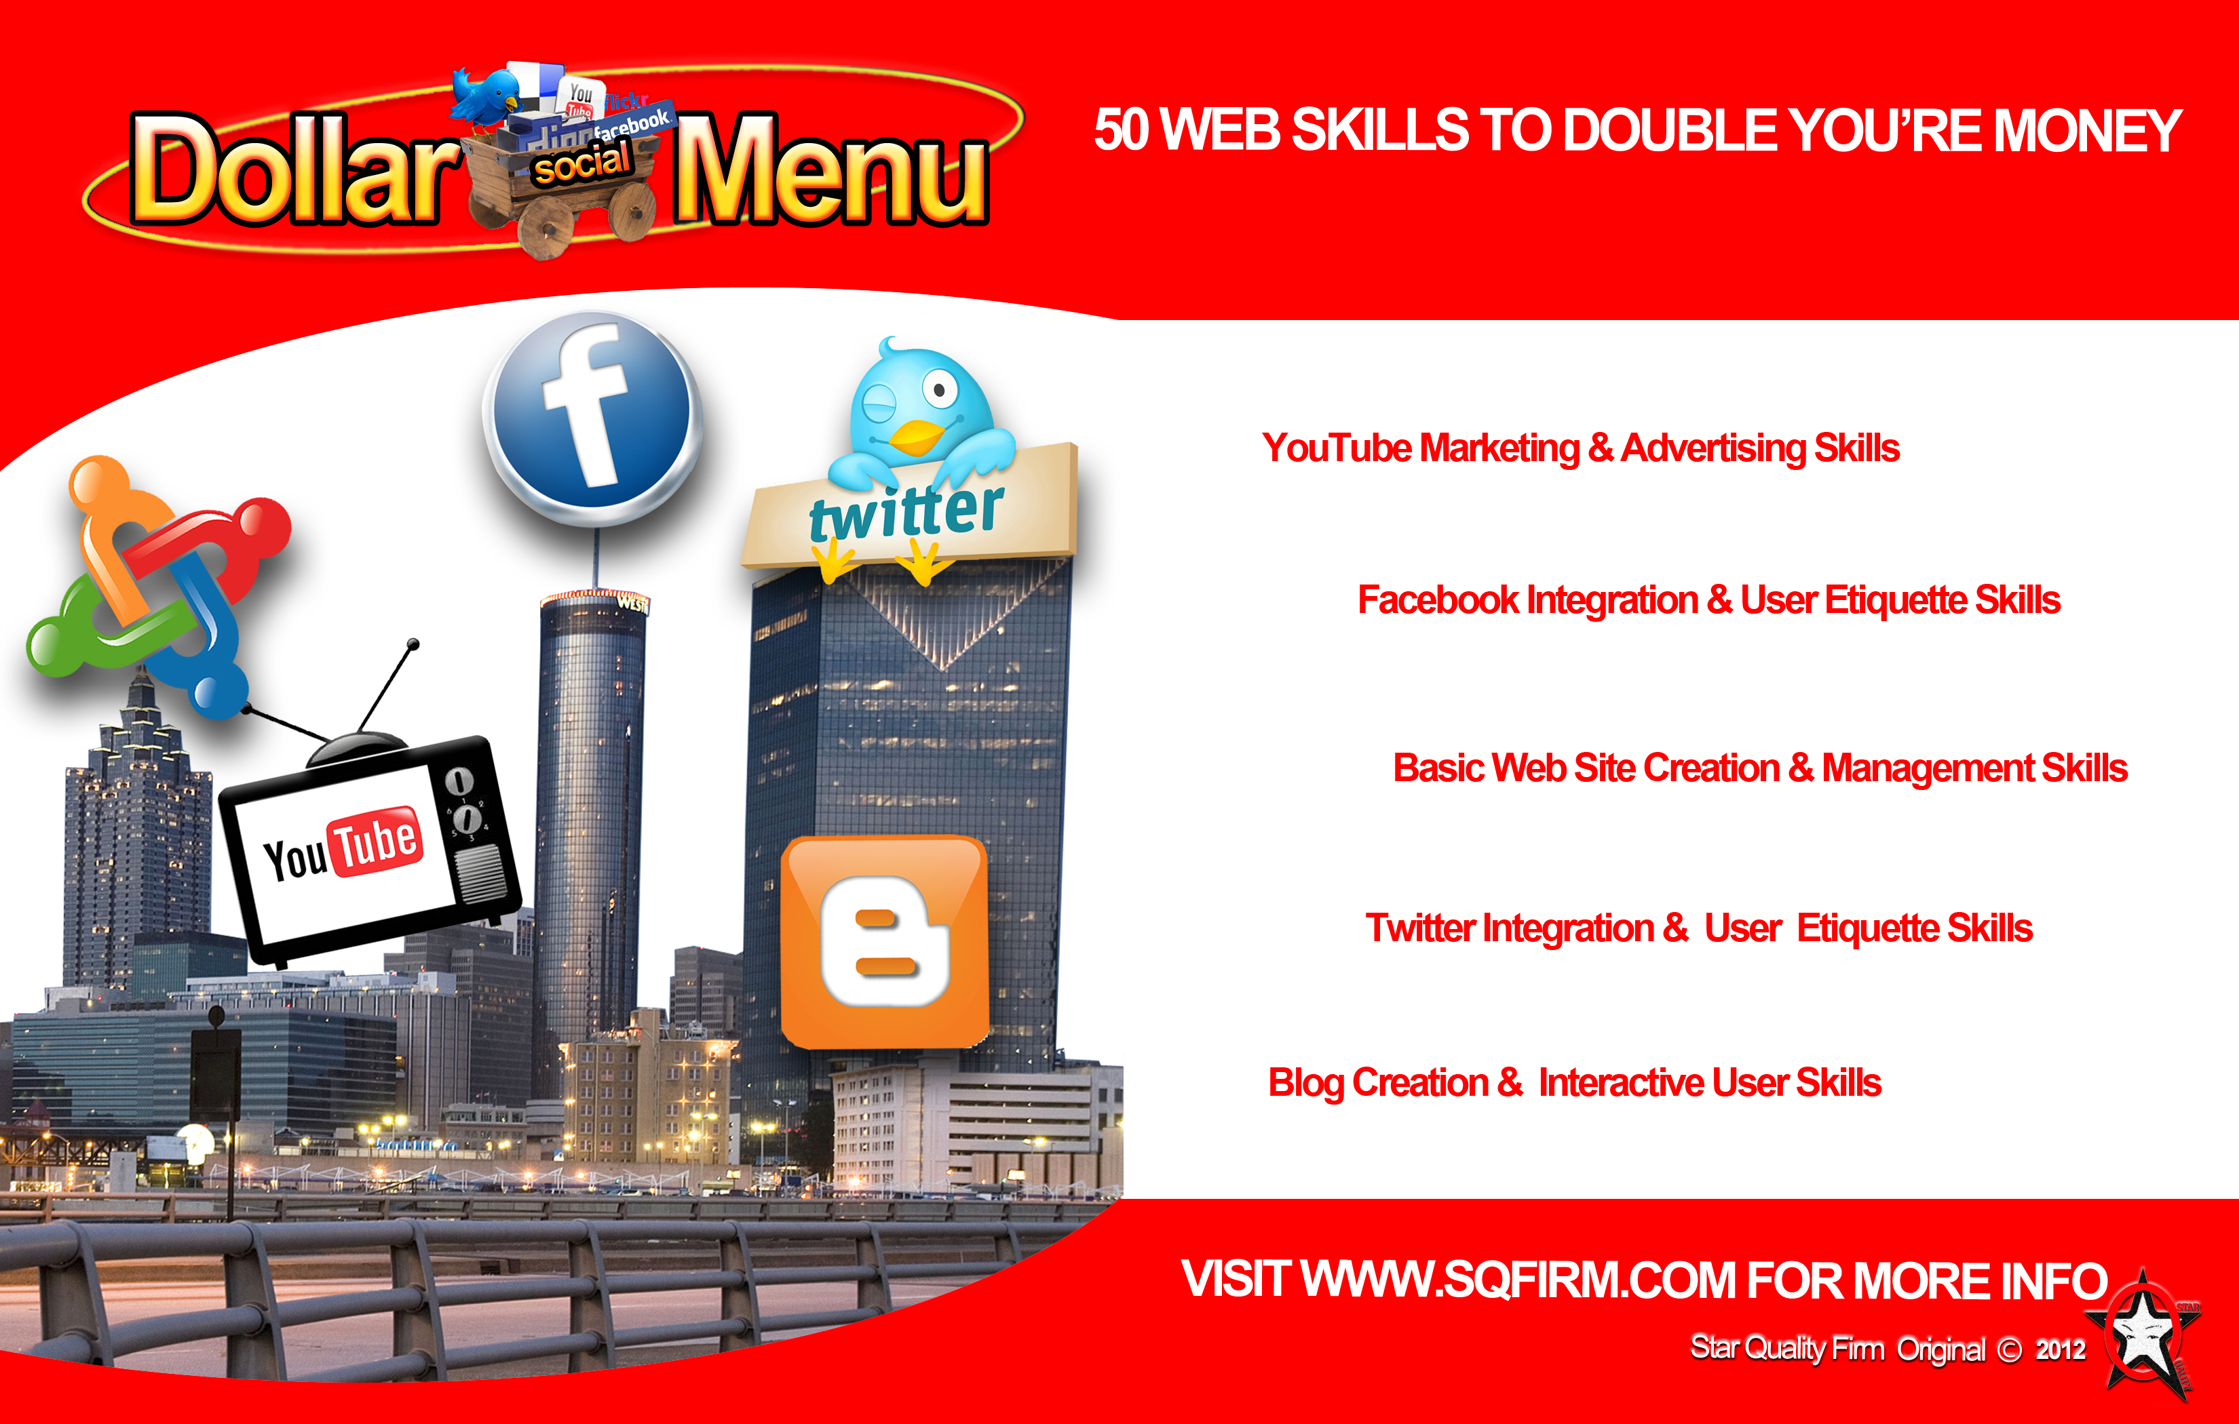
In a genuine effort to bring an awareness to the lack of minority participation and career trades in the Technology Field, Star Quality Firm has developed an affordable and easy to follow training program called “The Social Dollar Menu.”
This training course takes 50 of the top Social and Digital Media Skills know to corporations and makes them easily accessible to urban entrepreneurs and small businesses.
With the worldwide embrace of Social Media Technology setting many companies aside from others as reliable; customer friendly brands, Star Quality Firm has once again noticed the disconnect to these digital and social media skills in minority communities.
The Creation of the “Social Dollar Menu” Training course helps to bridge the gap between multiple forms of Digital Communications like Viral Videos, Commercials, EPK’s, iTunes and Social Media outlets such as Facebook, Twitter, YouTube & Linked In; and the small businesses minded minority who seeks make their company technology friendly to its consumers.
.

LEARN. SHARE. GROW.

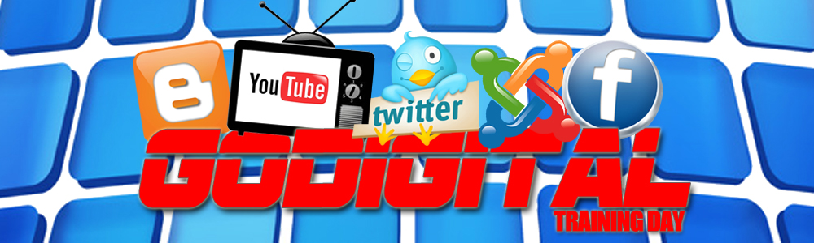

SCHEDULE OUTLINE
The #GODIGITAL Training Day will combine our Digital Communications Training Program “The Social Dollar Menu” with real life social opportunities to give our students a full life experience in the do’s and don’ts of utilizing Social Media to promote independent wealth for their business. All students who complete the Training Course will receive a Certificate of Completion and a copy of The Social Dollar Menu Reference Manual to celebrate their achievement.

ARE YOU UP TO A CHALLENGE?
8:00AM - 9:15AM
10 Basic WP Creation & Management Skills
9:20AM - 10:35AM
10 YouTube Marketing & Advertising Skills
10:40AM - 11:40AM
10 Blog Creation & Interactive User Skills

POWER LUNCH 11:50PM-2:30PM

2:45PM – 6:00PM
10 Twitter Integration & User Etiquette Skills
10 Facebook Marketing & Advertising Skills
Q&A OPEN DISCUSSION

CLASS SCHEDULE

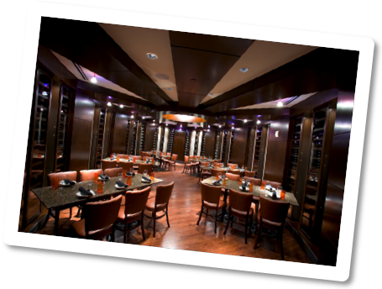
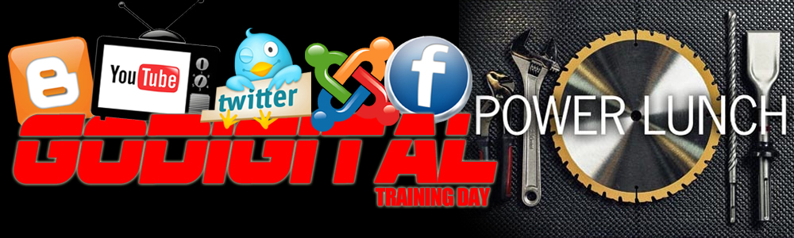
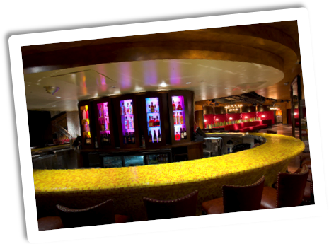

A Download of Information and Upload of Nourishment with 3 of the Digital Industries Top Content Providing Companies, The #GoDigital Power Lunch will allow our students to have a round table style business lunch with three of the digital media industries pace setters. Celebrating the art of social networking thru a historically powerful form of social communication, the lunch dates!
Students will have the opportunity to engage in a casual sit down power lunch with Star Quality Firm and some of the most powerful digital industry executives. Taking this opportunity to gain a more personalized outlook on their companies social media communication skills, discuss company ideas and more. This power lunch will take your social networking skills to the next level by practicing the art of the business lunch and closing the deal.

SCHEDULE OUTLINE

THE POWER OF THE BUSINESS LUNCH

EAT
DRINK
SHARE
CLOSE THE DEAL

Finish the registration off with a VIP Certificate Ceremony to celebration of your accomplishments of the class. Students who attent the full class schedule and our power lunch will automatically recieve a commmerative certificate of completion during an arranged graduation ceremony in the "#GODIGITAL Training Day."

DEDICATION DESERVES CELEBRATION

CEREMONY BENEFITS

RECOGINITION OF CLASS ACHIEVERS
ANNOUNCING LEADERSHIP & TEAM STRUCTURES
TEAM BUILDING & ROLE PLACEMENT
INFORMATION GATHERING AND NETWORKING
PRESENTATION OF GOLD INVESTMENT INTO GRADUATES

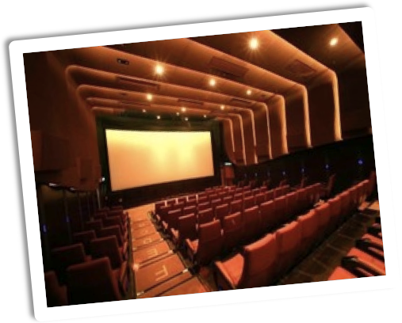
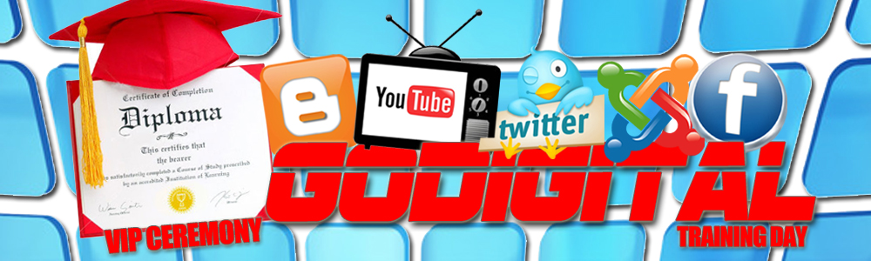
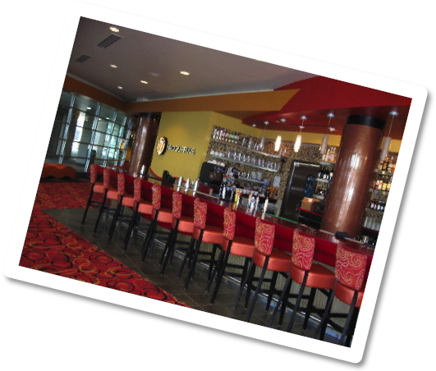
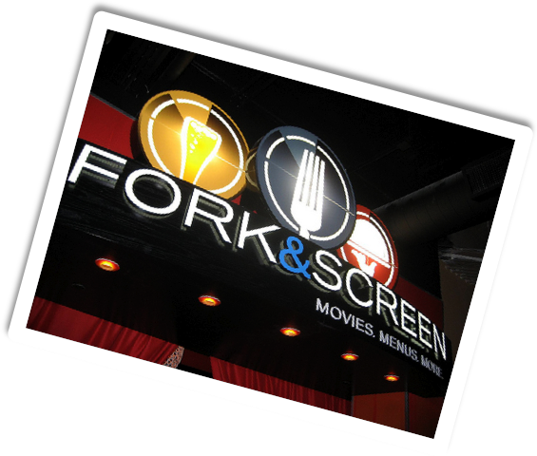

SCHEDULE OUTLINE


THE BENEFITS OF THE SOCIAL DOLLAR MENU

SIMPLE – ECONOMICAL - ACCESSIBLE
WHY DOES SOCIAL MEDIA = INDEPENDENT WEALTH

“Social media users extol their opinions and share various personal details on Internet platforms with the intention of having their thoughts and personalities validated by their followers The Internet is a playground for reciprocal social interaction and as members of a social environment, users expect feedback for any content they decide to make public.” – Shaleea “Lucki” Johnson

NUMBERS DON’T LIE

Duis tortor erat, mollis a, condimentum vel, interdum non, enim. Ut sed leo. Suspendisse lacus. Vestibulum a pede sit amet lorem dignissim vehicula. Vivamus gravida faucibus est. Maecenas faucibus eleifend diam. Suspendisse quis dui id nunc convallis scelerisque. Praesent sed massa vel ante cursus sodales. Nulla posuere, arcu sit amet rutrum iaculis, felis diam dapibus orci, eget pretium est nulla quis sem. Cras sapien nulla, congue ut, consequat nec, suscipit vitae, leo. Donec vel urna non neque auctor euismod. Vivamus mi.

Sed nisl sapien, pulvinar ut, feugiat nec, porta non, odio. Vestibulum vehicula elit ut dolor accumsan dapibus.
Vestibulum massa mi, tincidunt sed, bibendum eu, scelerisque sed, nibh. Etiam quis mi. Nam auctor, quam eget ultricies tempor, nisi elit vehicula lacus, vitae laoreet orci mi nec nisl.
Lorem Ipsum Dolor
[Street Address]
[City], [State][Postal Code]
[Recipient]
Address Line 1
Address Line 2
Address Line 3
Address Line 4

